

# **Amazon Platform Dissection**

## **Company Overview**

Amazon, founded by Jeff Bezos in 1994, has revolutionized the way people shop online, providing a vast marketplace for both sellers and buyers. Initially started as an online bookstore, Amazon has expanded its offerings to include a diverse range of products, from electronics to household items. With its customer-centric approach, Amazon has become a global e-commerce giant, known for its convenience, competitive pricing, and innovative services like Amazon Prime.

## **Product Dissection and Real-World Problems Solved by Amazon**

Amazon, a global e-commerce leader, has addressed various real-world challenges through its comprehensive product offerings and innovative solutions. By providing a platform where users can purchase almost anything with just a few clicks, Amazon has redefined shopping convenience, making it easier for people to access products and services from the comfort of their homes. This fundamental feature solves the problem of limited access to a wide variety of products, particularly for individuals in remote or underserved areas.

Amazon's efficient delivery system, including same-day and next-day delivery options, has revolutionized the logistics industry, addressing the challenge of slow and unreliable delivery services. Furthermore, Amazon's user review and rating system enhances the shopping experience by allowing customers to make informed purchasing decisions based on feedback from other users. By tackling these real-world problems, Amazon has set new standards in the e-commerce industry, fostering a seamless and reliable shopping experience for millions of customers worldwide.

## **Case Study: Real-World Problems and Amazon's Innovative Solutions**

Amazon has not only transformed the way we shop but has also provided innovative solutions to several significant real-world challenges. By understanding user needs and leveraging technology, Amazon has positioned itself as a solution-driven platform that enhances convenience, fosters informed decision-making, and streamlines logistics.

### **Problem 1: Limited Access to a Variety of Products**

**Real-World Challenge:** In many regions, access to a diverse range of products is limited, making it challenging for individuals to find and purchase items they need.

**Amazon's Solution:** Amazon's vast marketplace offers an extensive selection of products across various categories, ensuring that users can find almost anything they need. By connecting sellers from around the world with buyers, Amazon addresses the issue of limited access, providing a convenient and comprehensive shopping solution.

### **Problem 2: Slow and Unreliable Delivery Services**

**Real-World Challenge:** Traditional delivery services often suffer from delays and unreliability, causing frustration for customers awaiting their purchases.

**Amazon's Solution:** Amazon's advanced logistics network, including services like Amazon Prime, offers fast and reliable delivery options, including same-day and next-day delivery. This innovative approach addresses the challenge of slow delivery services, enhancing customer satisfaction and trust in the platform.

### **Problem 3: Lack of Informed Purchasing Decisions**

**Real-World Challenge:** Customers often face difficulties in making informed purchasing decisions due to a lack of reliable product information and reviews.

**Amazon's Solution:** Amazon's user review and rating system allows customers to share their experiences and provide feedback on products. This feature helps prospective buyers make informed decisions, mitigating the challenge of uncertainty in online shopping and fostering a community of informed consumers.

### **Problem 4: Inconvenience in Shopping**

**Real-World Challenge:** Traditional shopping can be time-consuming and inconvenient, especially for individuals with busy schedules or limited mobility.

**Amazon's Solution:** Amazon's user-friendly platform allows customers to shop from the comfort of their homes, offering a seamless and convenient shopping experience. With features like personalized recommendations and a user-friendly interface, Amazon addresses the inconvenience of traditional shopping methods, making it easier for users to find and purchase products quickly.

## 

## **Top Features of Amazon**

1. **User Profiles:** Amazon allows users to create personal profiles with information such as usernames, email addresses, and registration dates. This creates a personalized shopping experience for each user.
2. **Products:** Amazon offers a vast array of products, each with detailed descriptions, prices, and stock availability. Users can browse and purchase items across various categories.
3. **Orders:** Users can place orders for multiple products, with detailed information about the order date, total amount, and associated order items.
4. **Order Items:** Each order can contain multiple products, with specific details about the quantity and price of each item.
5. **Reviews:** Users can provide feedback on products they have purchased, including ratings and comments, helping other users make informed decisions.
6. **Wishlist:** Users can save products they are interested in to their wishlist, allowing them to easily find and purchase these items later.

## 

## 

## **Schema Description**

The schema for AmazonPlatform involves multiple entities that represent different aspects of the platform. These entities include Users, Products, Orders, OrderItems, Reviews, and Wishlist. Each entity has specific attributes that describe its properties and relationships with other entities.

### **User Entity:**

* **UserID (Primary Key):** A unique identifier for each user.
* **Username:** The chosen username for the user's account.
* **Email:** The user's email address for account-related communication.
* **Password:** The user's password for account security.
* **RegistrationDate:** The date when the user joined AmazonPlatform.

### **Product Entity:**

* **ProductID (Primary Key):** A unique identifier for each product.
* **Name:** The name of the product.
* **Description:** A detailed description of the product.
* **Price:** The price of the product.
* **StockQuantity:** The quantity of the product available in stock.

### **Order Entity:**

* **OrderID (Primary Key):** A unique identifier for each order.
* **UserID (Foreign Key referencing User Entity):** The user who made the order.
* **OrderDate:** The date when the order was placed.
* **TotalAmount:** The total amount of the order.

### **OrderItem Entity:**

* **OrderItemID (Primary Key):** A unique identifier for each order item.
* **OrderID (Foreign Key referencing Order Entity):** The order to which the item belongs.
* **ProductID (Foreign Key referencing Product Entity):** The product being ordered.
* **Quantity:** The quantity of the product in the order.
* **Price:** The price of the product at the time of the order.

### **Review Entity:**

* **ReviewID (Primary Key):** A unique identifier for each review.
* **ProductID (Foreign Key referencing Product Entity):** The product being reviewed.
* **UserID (Foreign Key referencing User Entity):** The user who wrote the review.
* **Rating:** The rating given by the user.
* **Comment:** The textual feedback provided by the user.
* **ReviewDate:** The date when the review was posted.

### **Wishlist Entity:**

* **WishlistID (Primary Key):** A unique identifier for each wishlist item.
* **UserID (Foreign Key referencing User Entity):** The user who created the wishlist.
* **ProductID (Foreign Key referencing Product Entity):** The product added to the wishlist.

## 

## 

## 

## 

## 

## 

## 

## 

## **ER Diagram**

Below is the Entity-Relationship (ER) diagram representing the schema of AmazonPlatform:

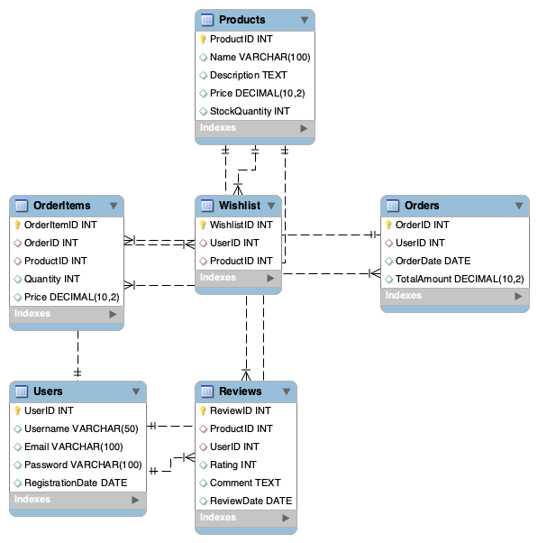

## **Conclusion**

In this case study, we explored the design of AmazonPlatform's schema and Entity-Relationship diagram. Amazon has revolutionized the way people shop online, providing a comprehensive and user-friendly platform that addresses various real-world challenges. The platform's intricate data model, consisting of entities like users, products, orders, order items, reviews, and wishlists, forms the foundation for its seamless functionality. By understanding this schema, we gain insight into how Amazon effectively manages the complexities of user interactions and product management, contributing to its widespread popularity and continued growth in the e-commerce industry.